
Jenkins Task -1
1.Install Jenkins and Run on Port 8081
- launch one ec2 and follow below steps
- Download jenkins Repo:
- sudo wget -O /etc/yum.repos.d/jenkins.repo https://pkg.jenkins.io/redhat-stable/ jenkins.repo
- Import the jenkins key:
- sudo rpm --import https://pkg.jenkins.io/redhat-stable/jenkins.io-2023.key

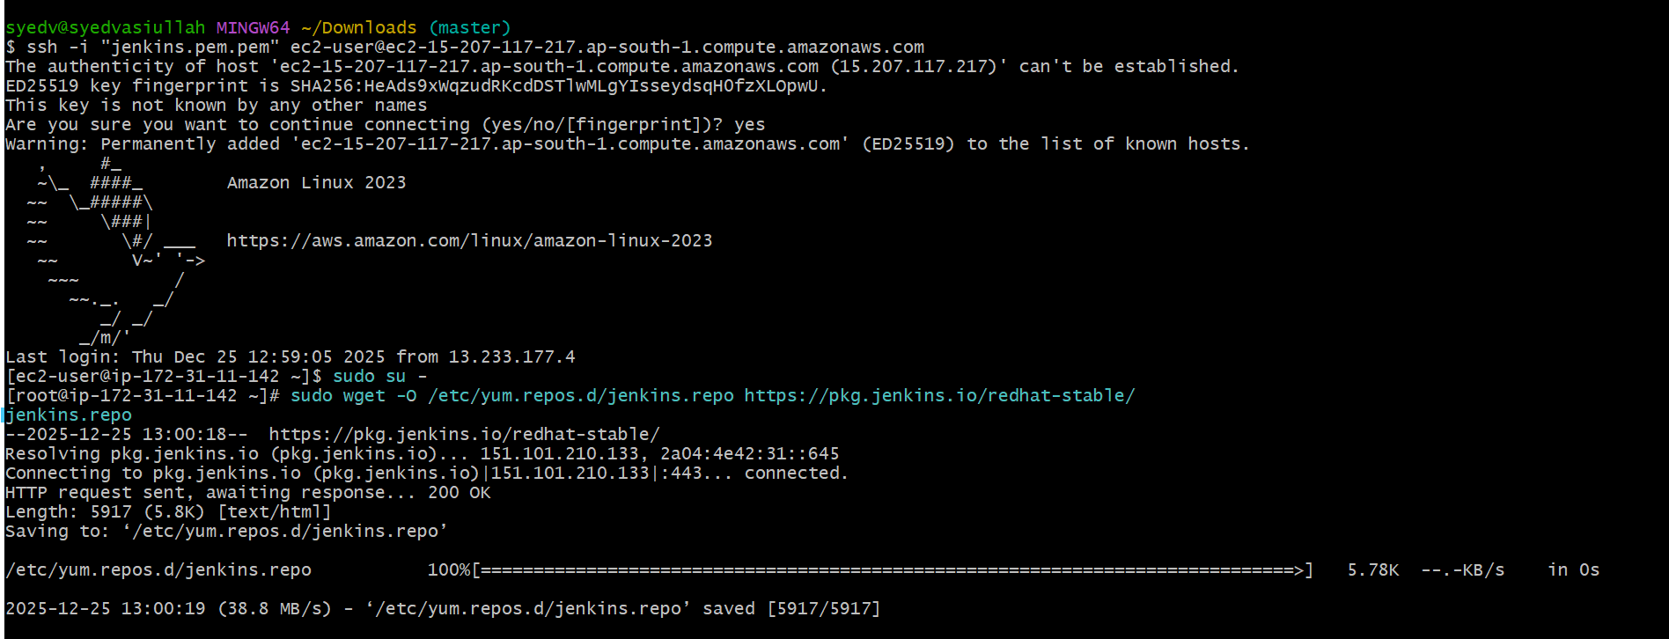

- sudo yum install java-17-amazon-corretto -y
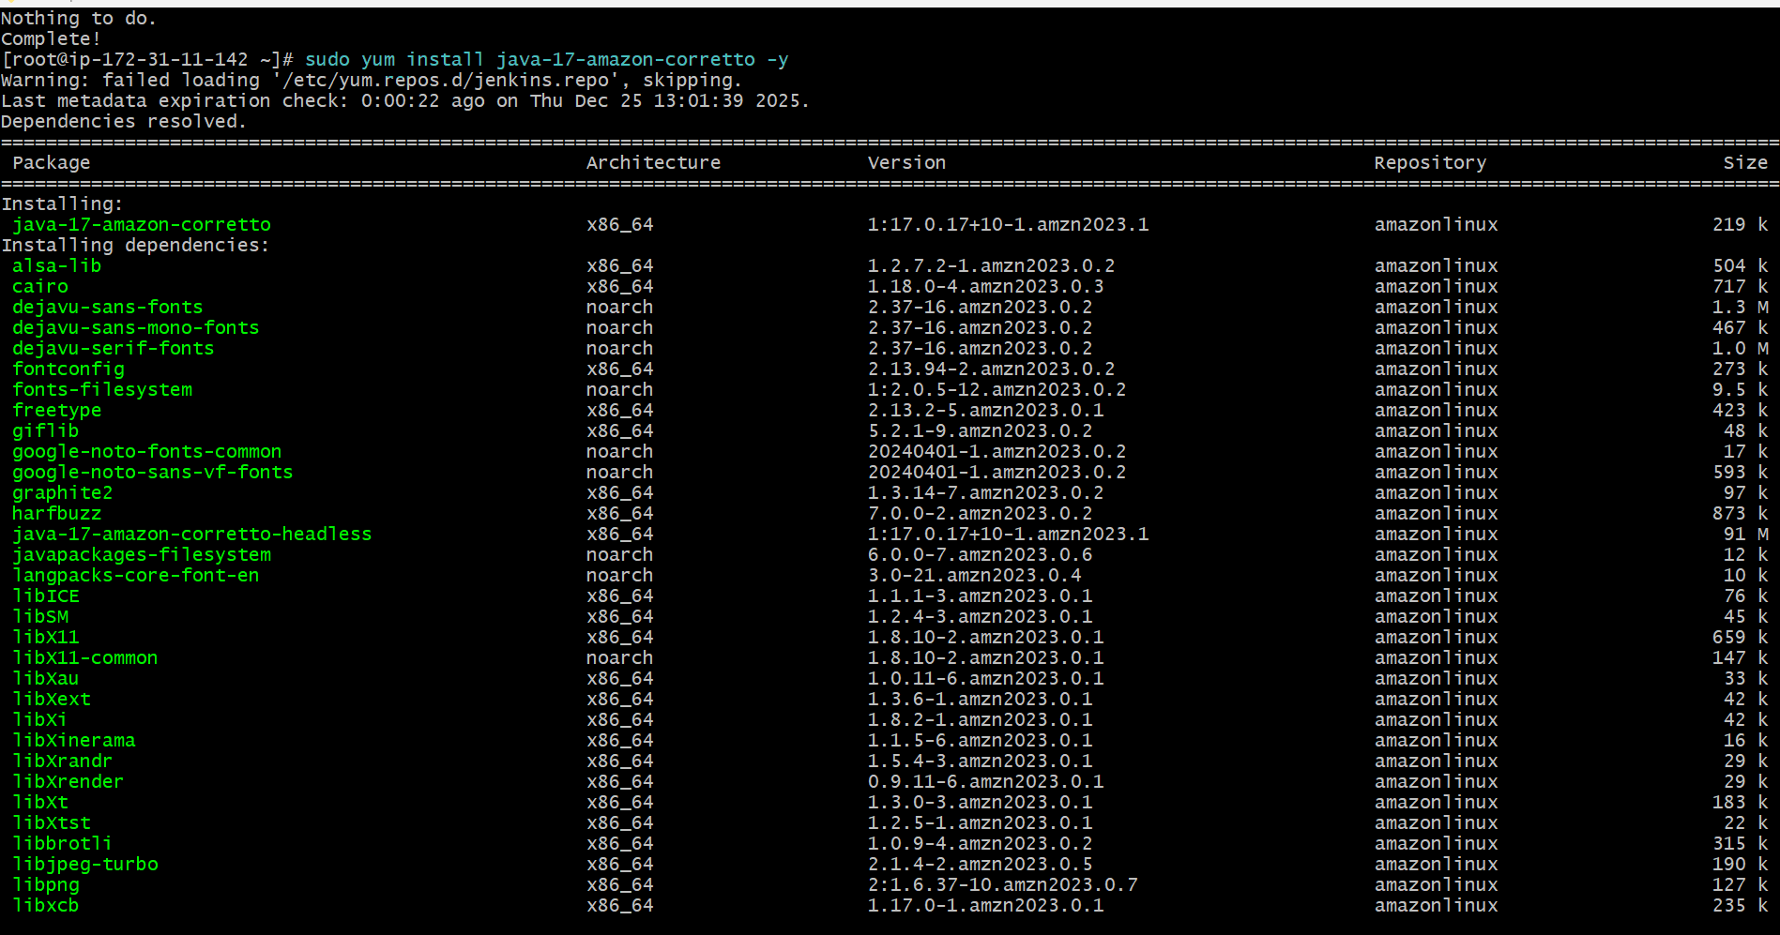
- sudo yum install jenkins

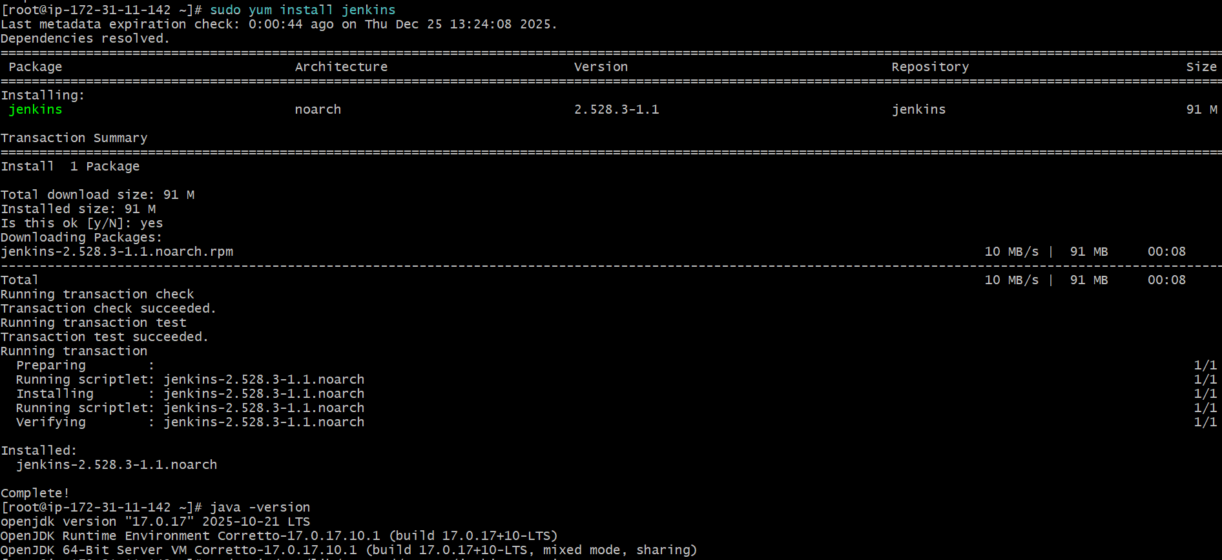
- Open Jenkins service file
- sudo vi /usr/lib/systemd/system/jenkins.service
- Find this line (very important) Environment="JENKINS_PORT=8080
- Change 8080 → 8081
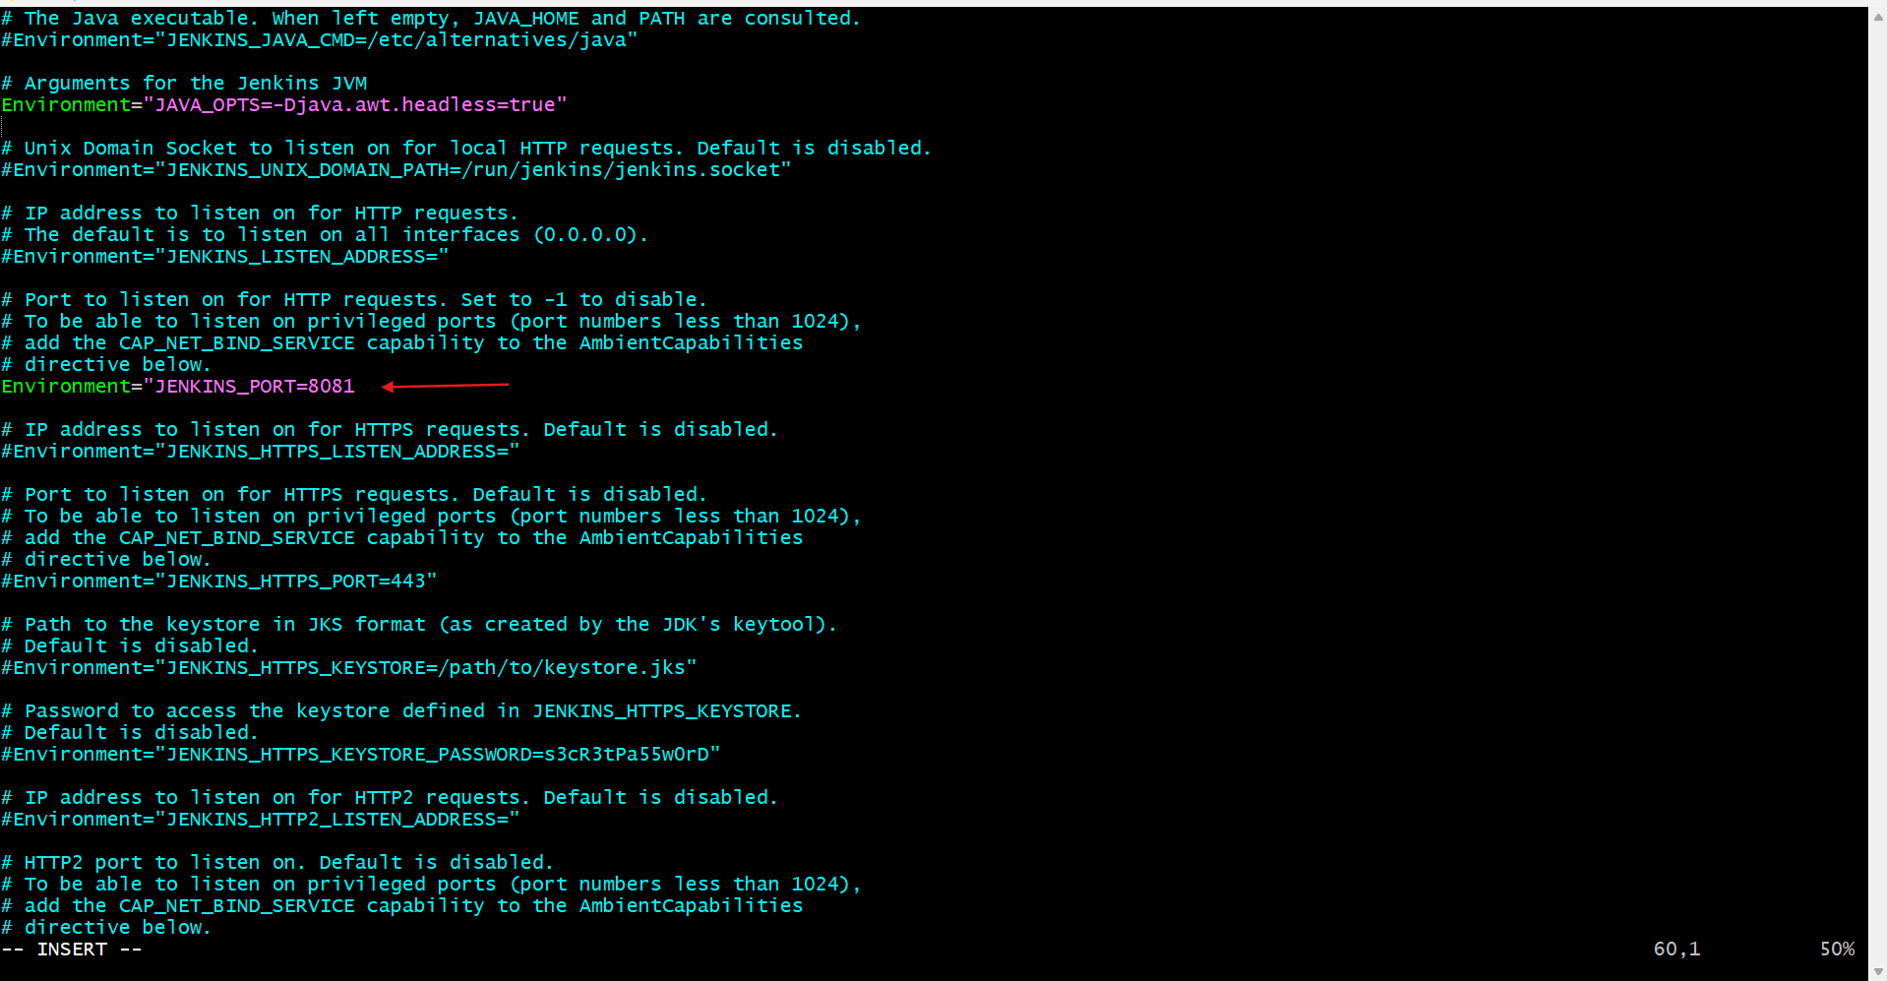
- sudo systemctl start jenkins
- Sudo systemctl status jenkins
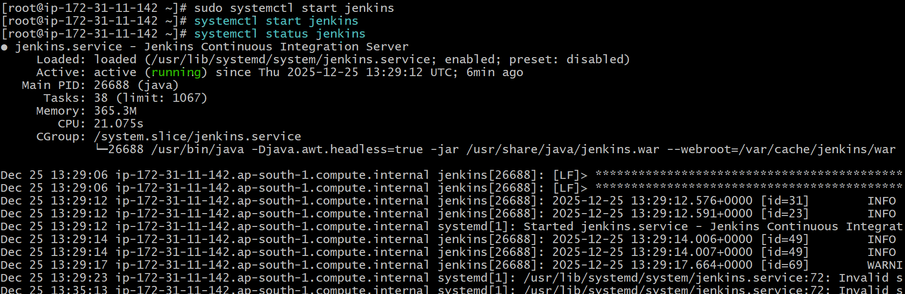

- Access Jenkins
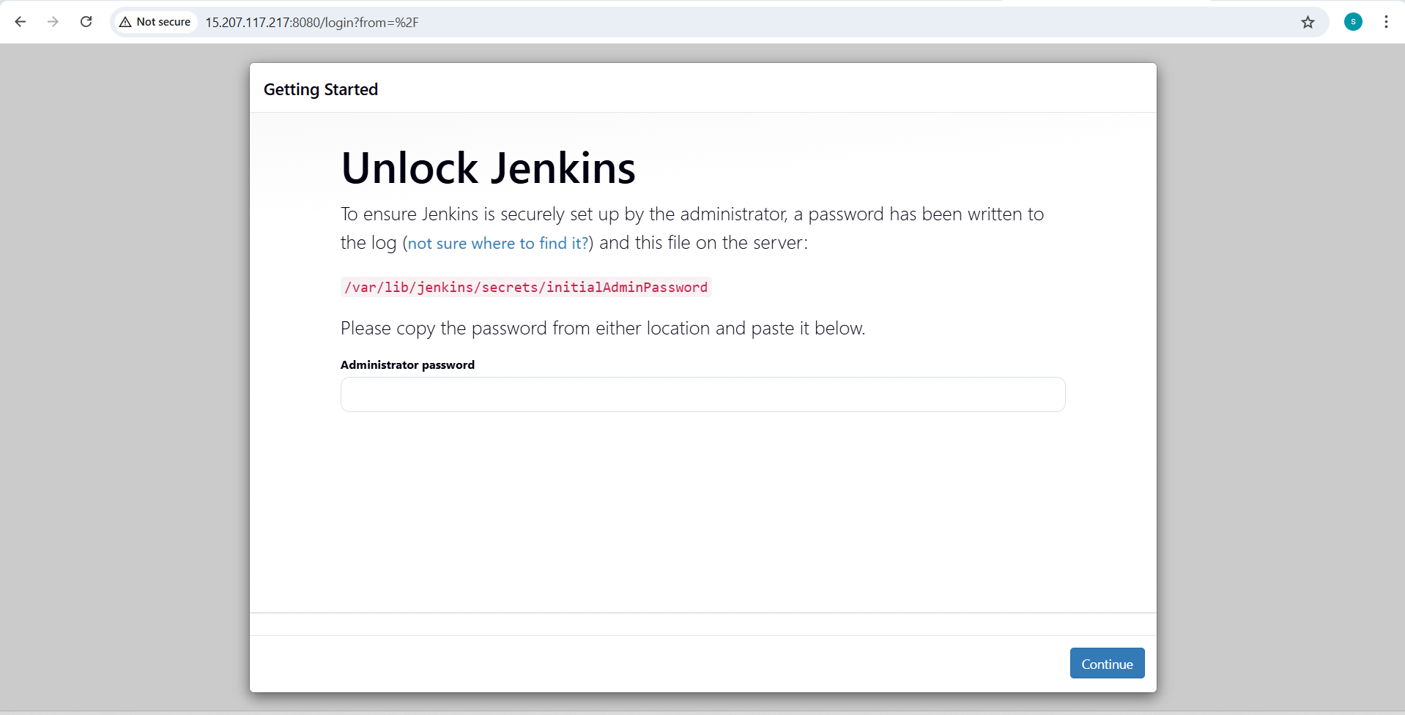
- jenkins is running in port 8081
Sudo cat /var/lib/jenkins/secrets/initialAdminPassword
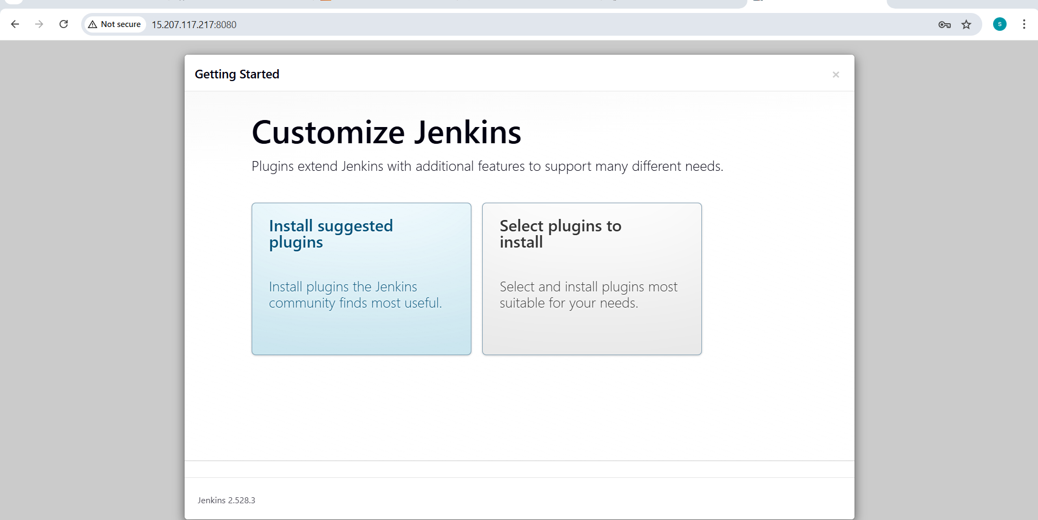

Fill like this (example):
• Username: admin
• Password: (your choice)
• Confirm password
• Full name: vasi
• Email: optional
Click Save and Continue
- Jenkins URL
http://:8081/<EC2-PUBLIC-IP>:8081/
Click Save and Finish → Start using Jenkins
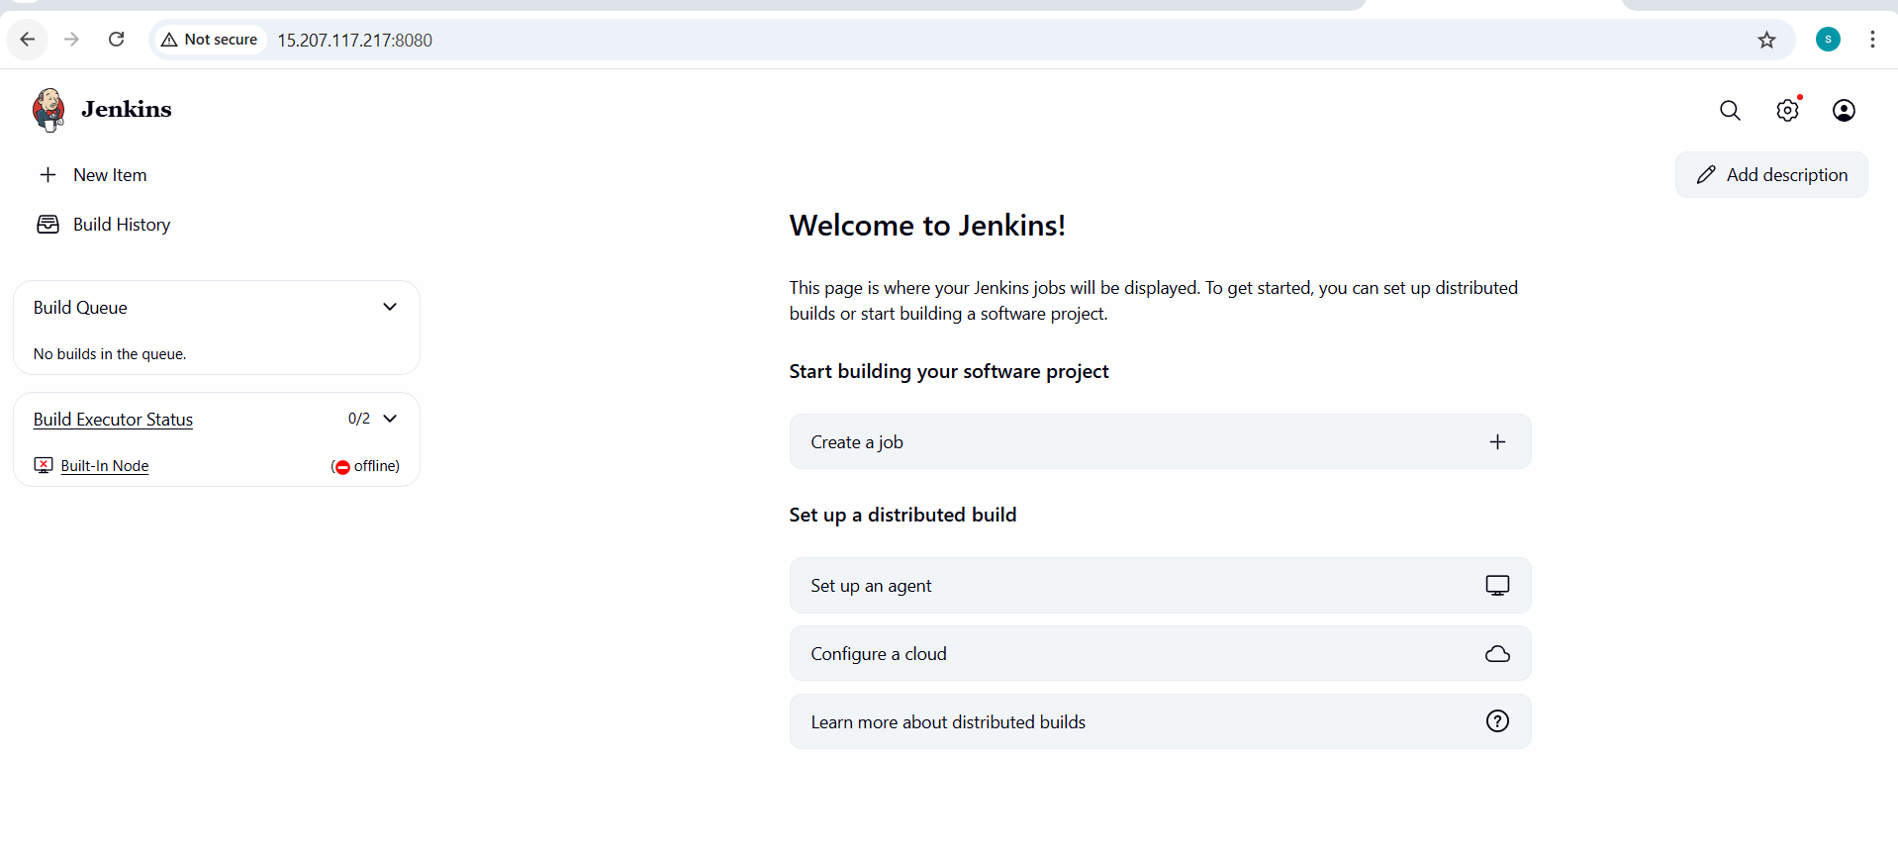
2.Secure Jenkins Server.
- change the password in security and remove the
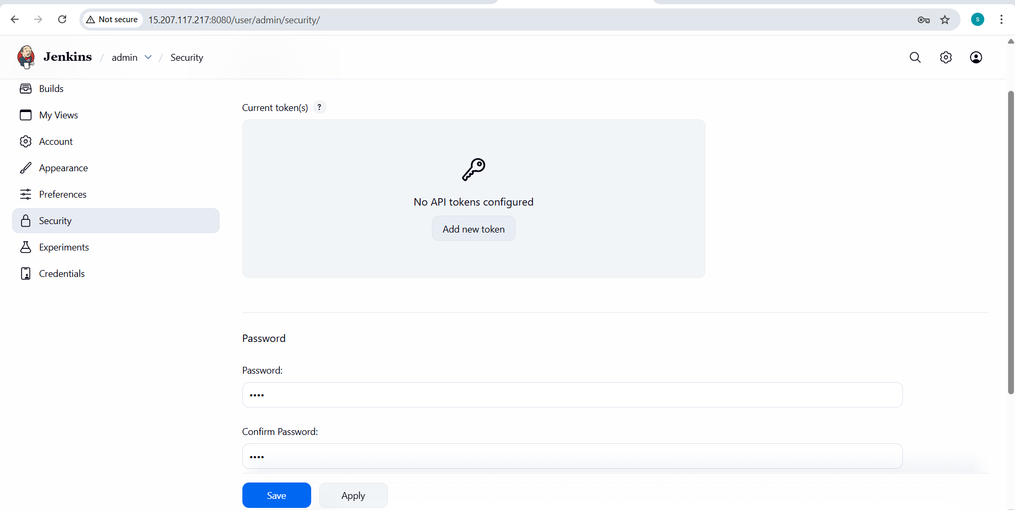
- Removed the initial admin password

3.Create users called DevOps, Testing in Jenkins with Limited access.
- Create Users
- Go to Manage Jenkins → Manage Users
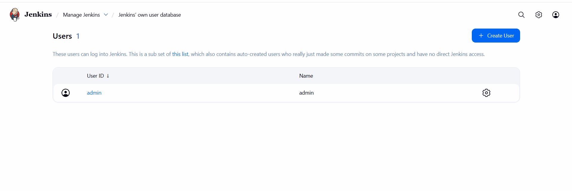
- Create DevOps User
- Click Create User
- Enter the following details:
- Username: DevOps
- Password: set password
- Confirm Password: same password
- Full Name: DevOps User
- Email: optional
- Click Create User

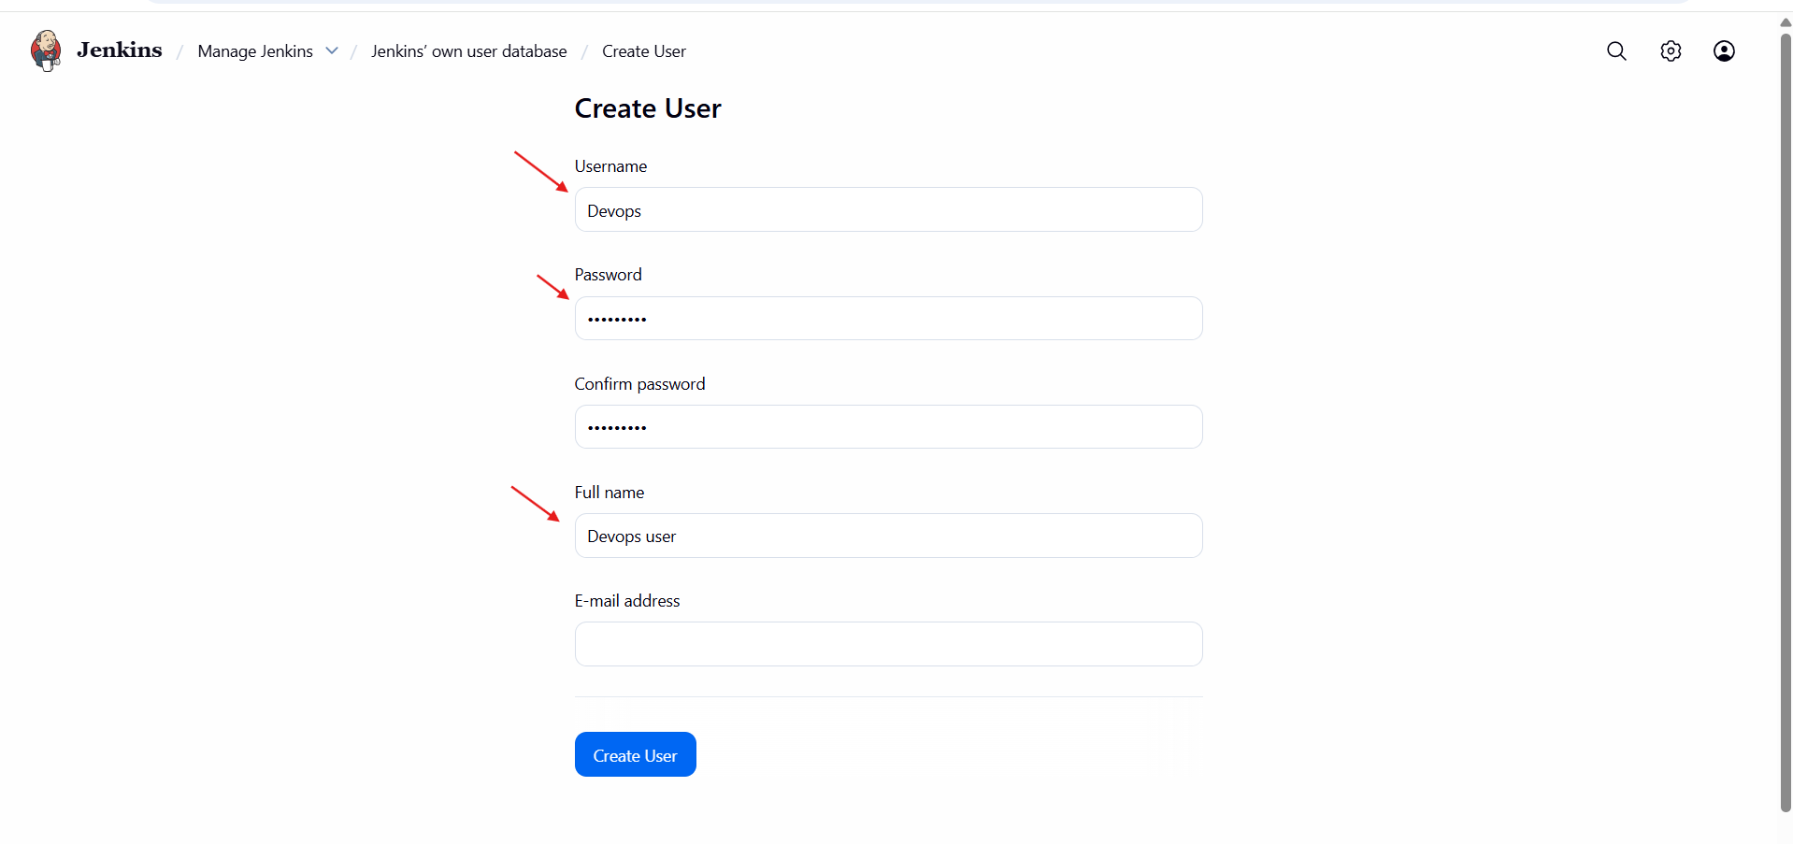
- Create Testing User
- Click Create User
- Enter the following details:
- Username: Testing
- Password: set password
- Confirm Password: same password
- Full Name: Testing User
- Email: optional
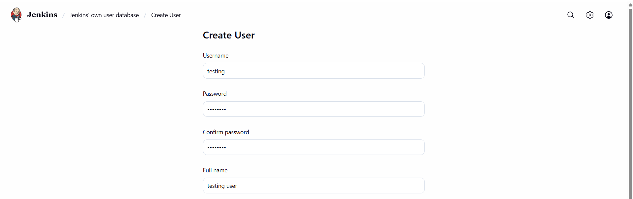
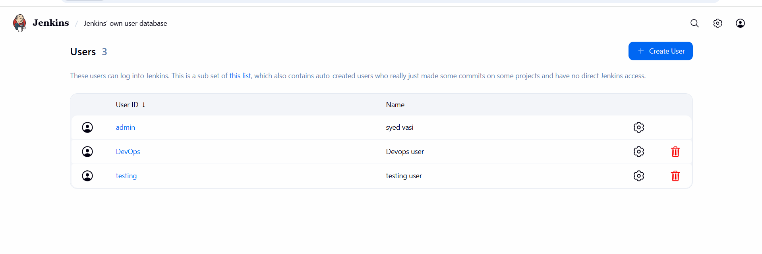
- Verify Users
- Ensure the following users exist:
• Admin user (created during setup)
• DevOps
• Testing
- Now for giving limited access we have to install a plugins
- And select the role-based authorisation strategy
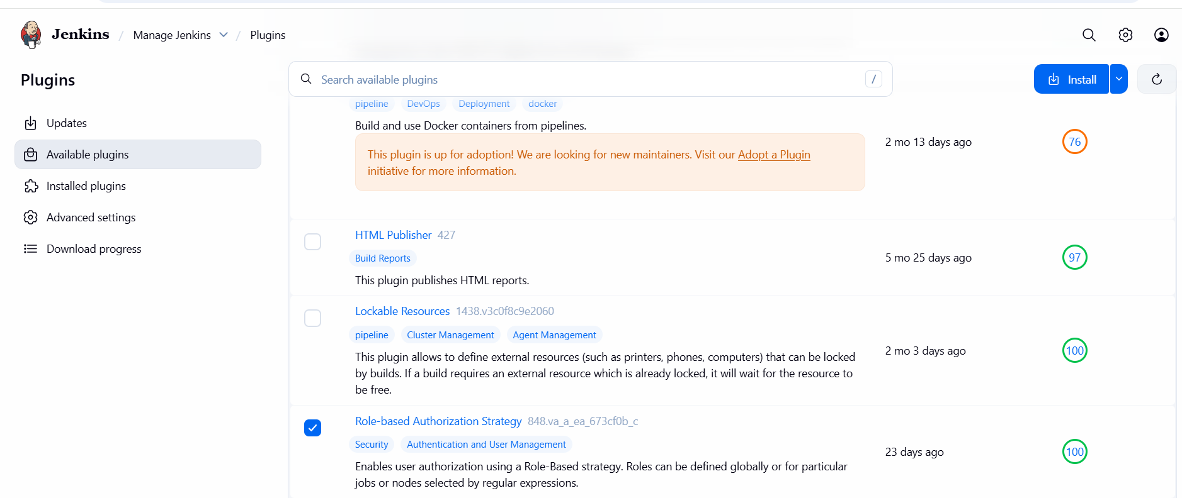
- Then go to security for authanticater tab.
- Then gave a permissons to the user.
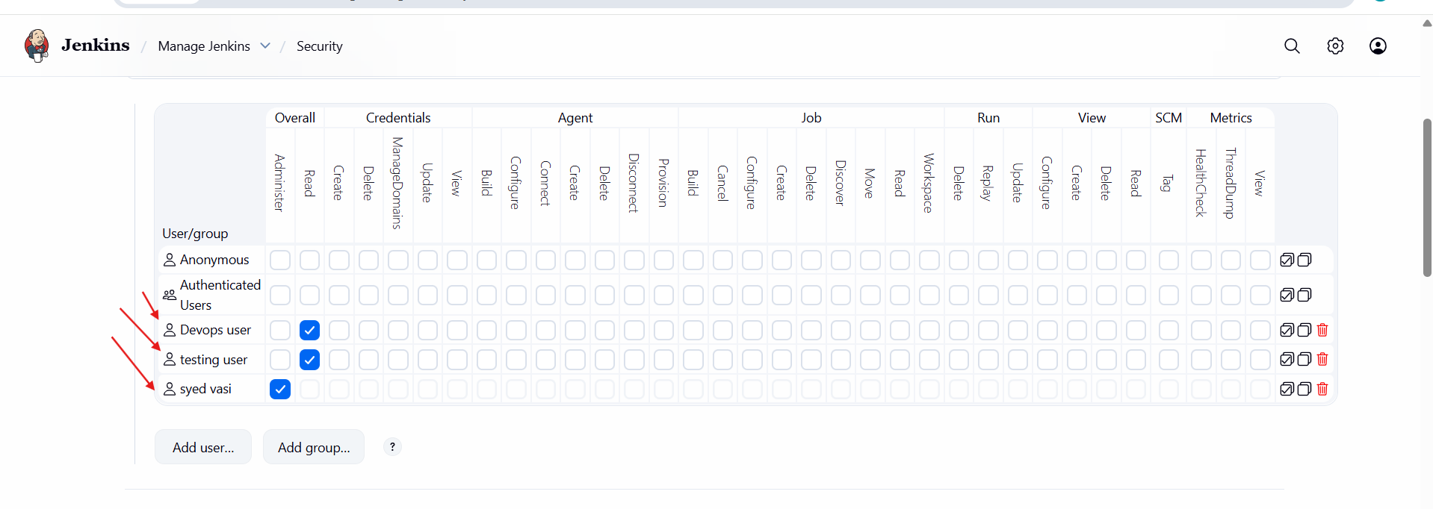
- Final Result
• Jenkins admin user exists
• DevOps and Testing users created successfully
• Users can log in to Jenkins
4.Configure Labels & Restrict Jobs to Run on Label Only
- Here the explanation about label and restrict jobs.
- Go to manage Jenkins first.
- Then go to plugins >> nd available plugins >> node label parameter >> install
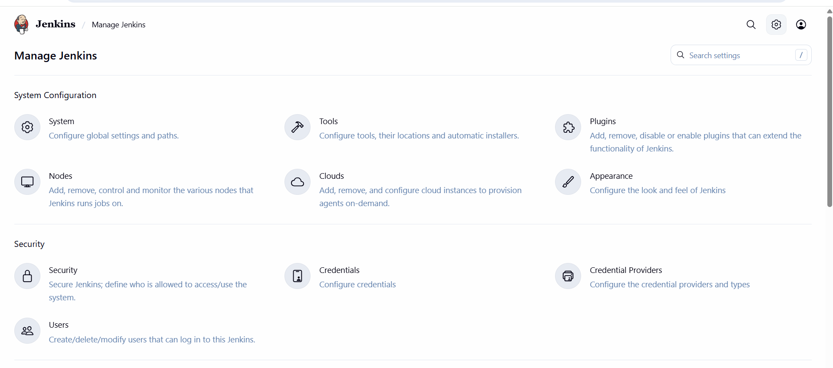
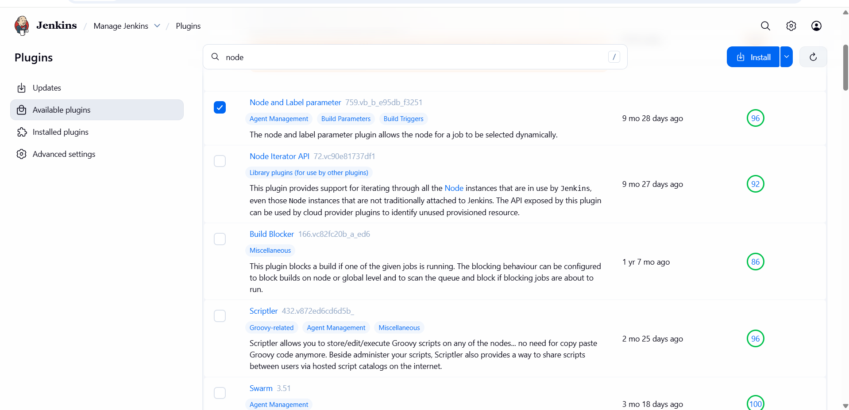

- Then in manage Jenkins >> node > check the node. And save
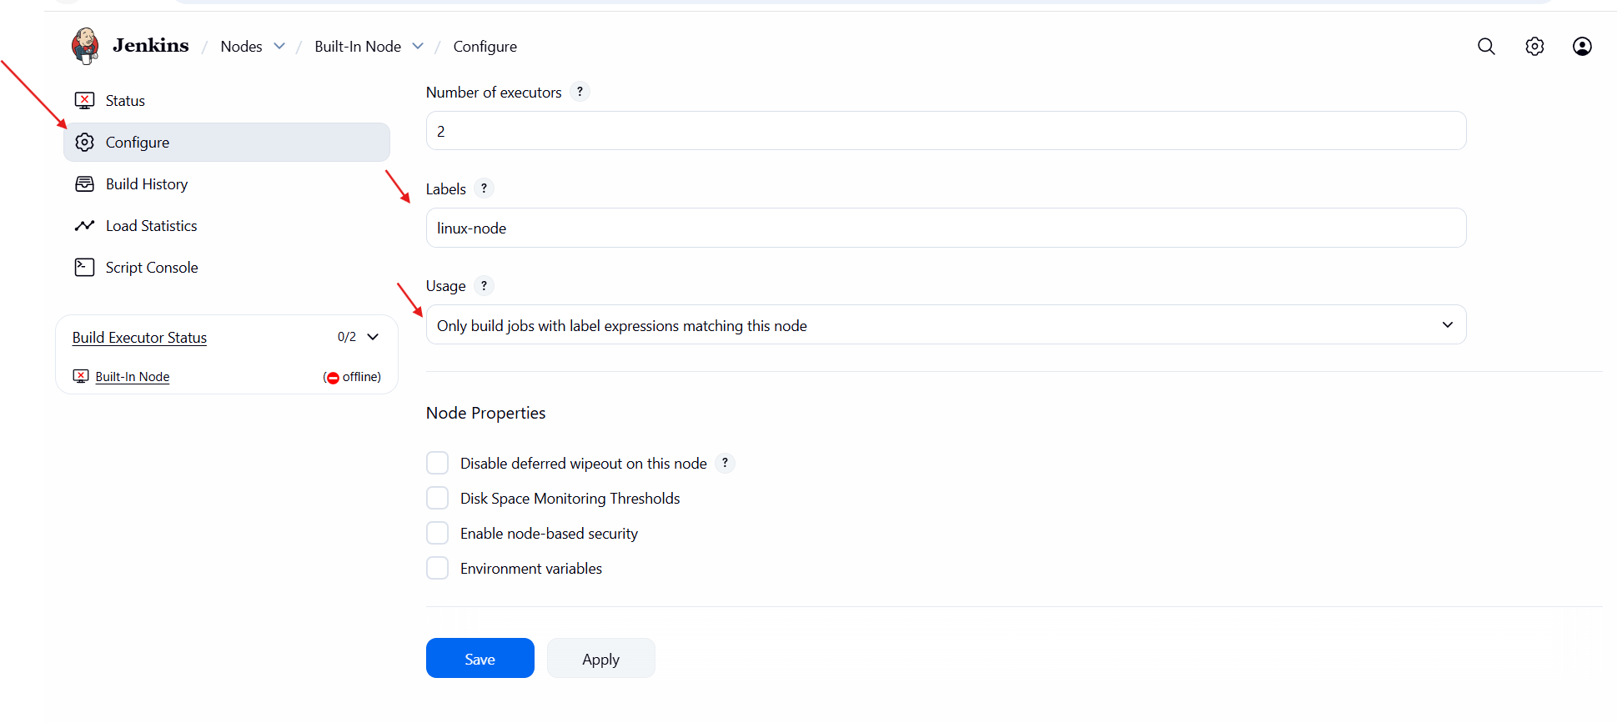
- change the free space threshold value to 0.1 gb in node conf
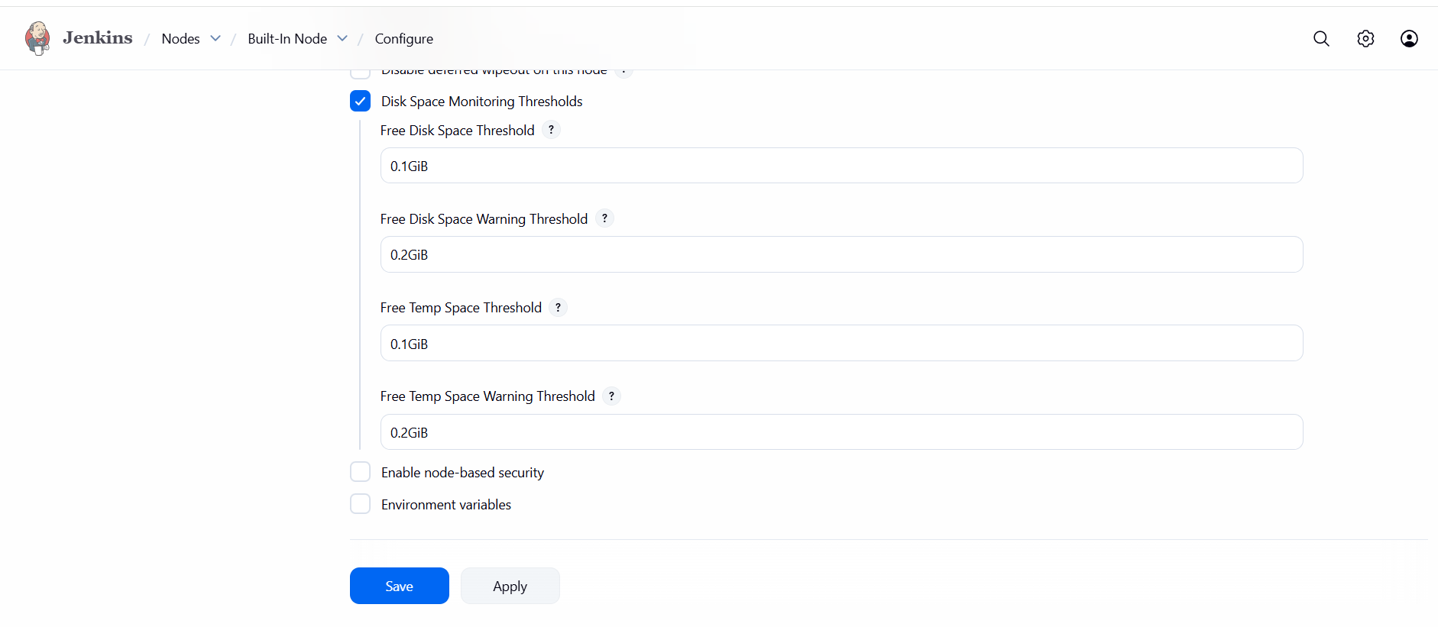
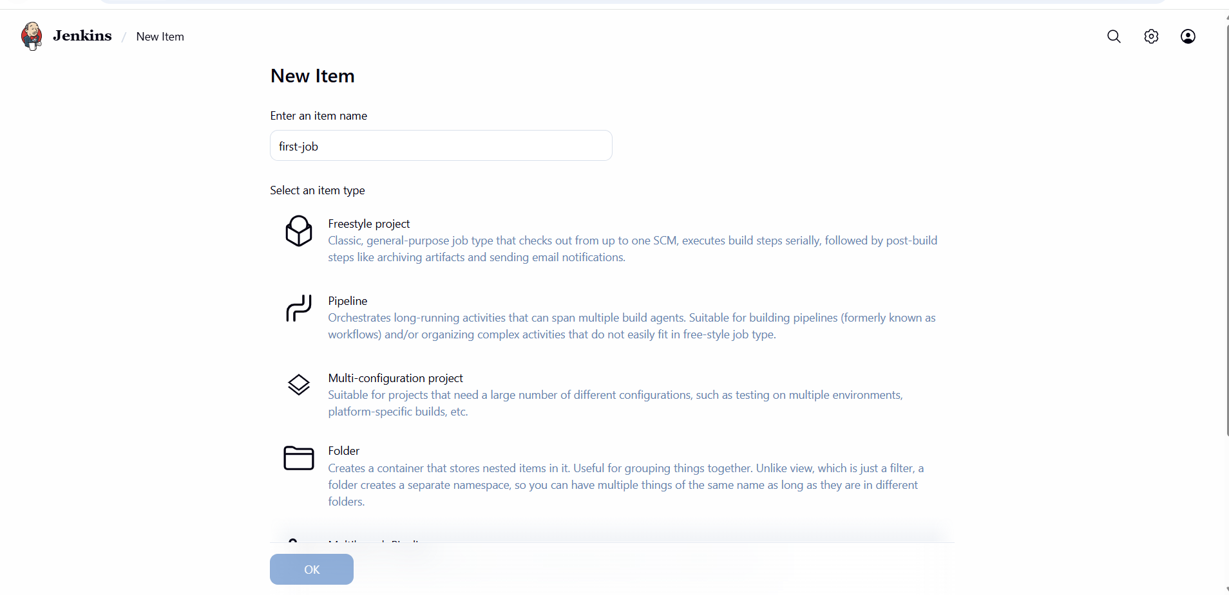
- Then connect to the your instance nd check the git version. Sudo yum install git -y
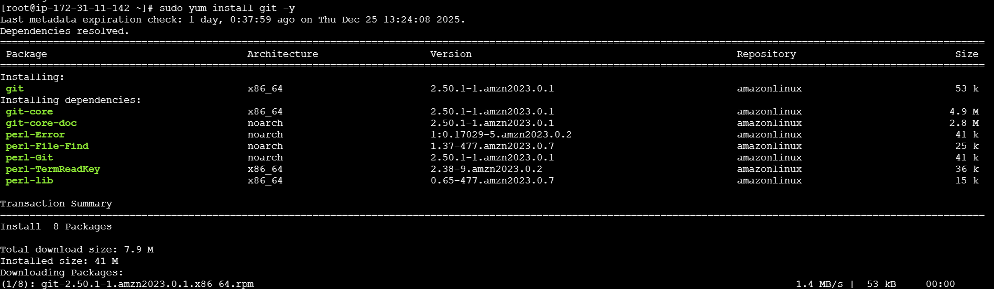
- If its not available then use “yum install git -y”
- Then the error will gone.
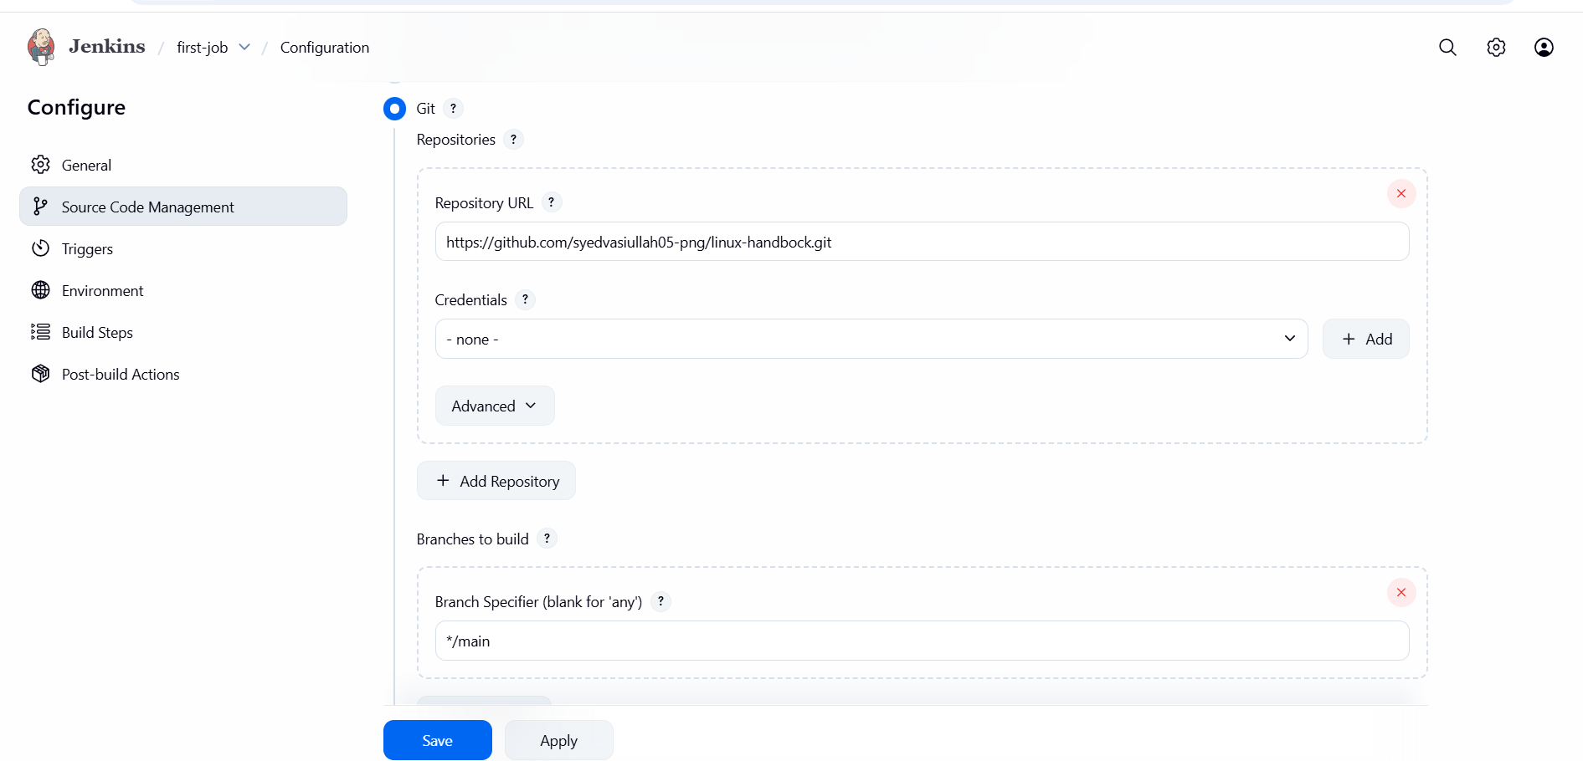
- And save changes
- Now click build now
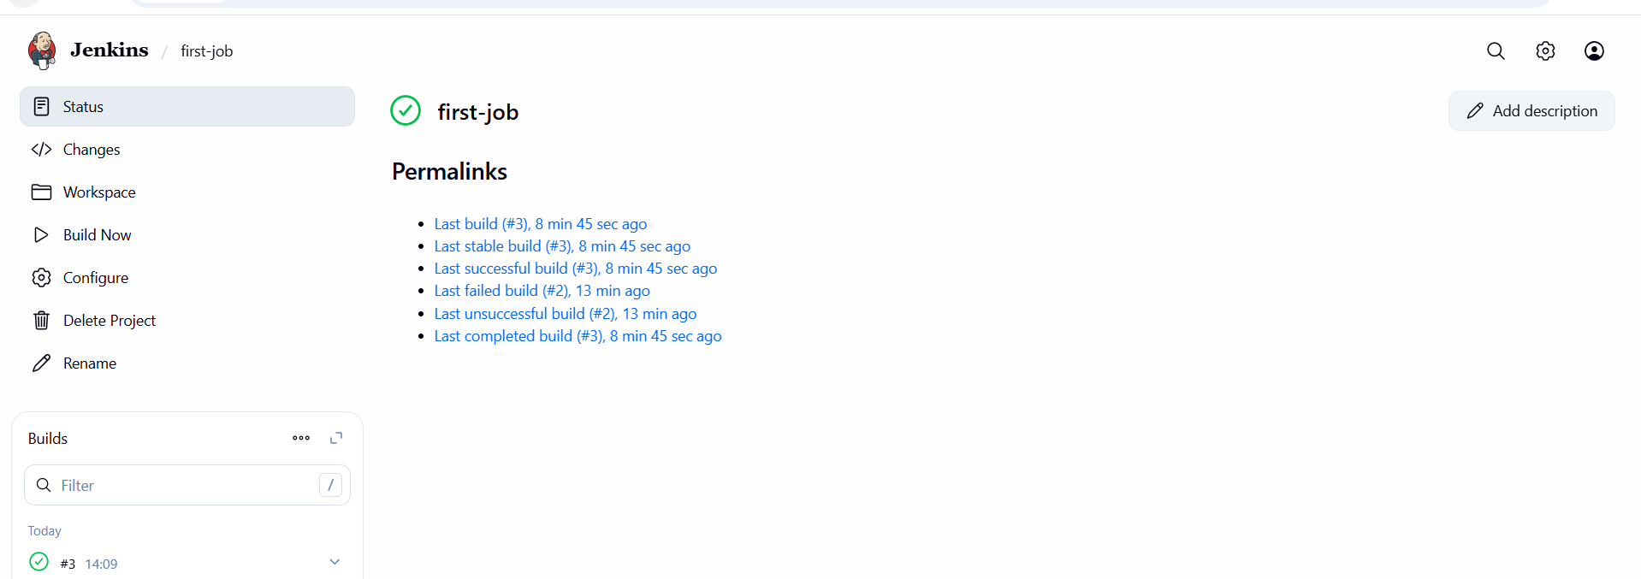
- check console output
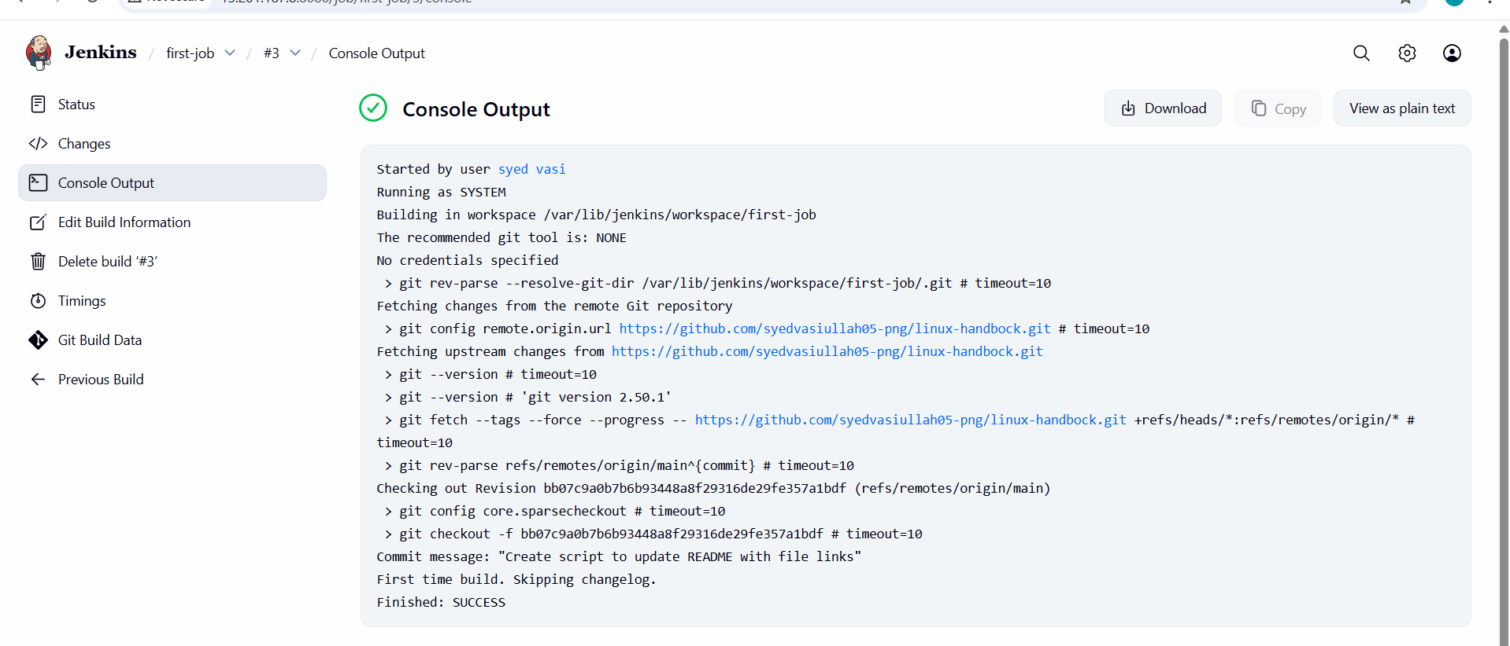
- Now check the node labels
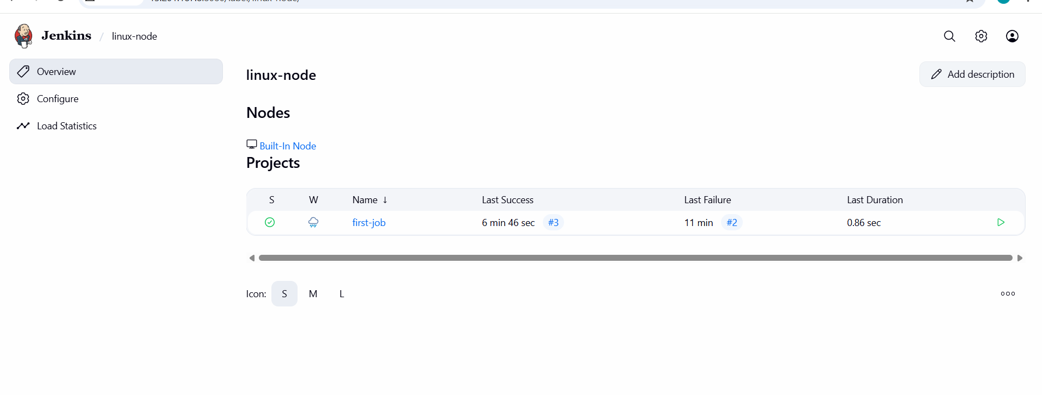

5.Create Three sample jobs using the below URL https://github.com/syedvasiullah05-png/linux-handbock.git
- Create Three Sample Jenkins Jobs
GitHub Repository Used:
https://github.com/syedvasiullah05-png/linux-handbock.git
- Go to the dashboard of jenkins.
- Create a new item.
- Then gave a name of that.in discrip on.
- Nd choose git nd copy the repo url.
- And save.
- Do same thing other 2 jobs also

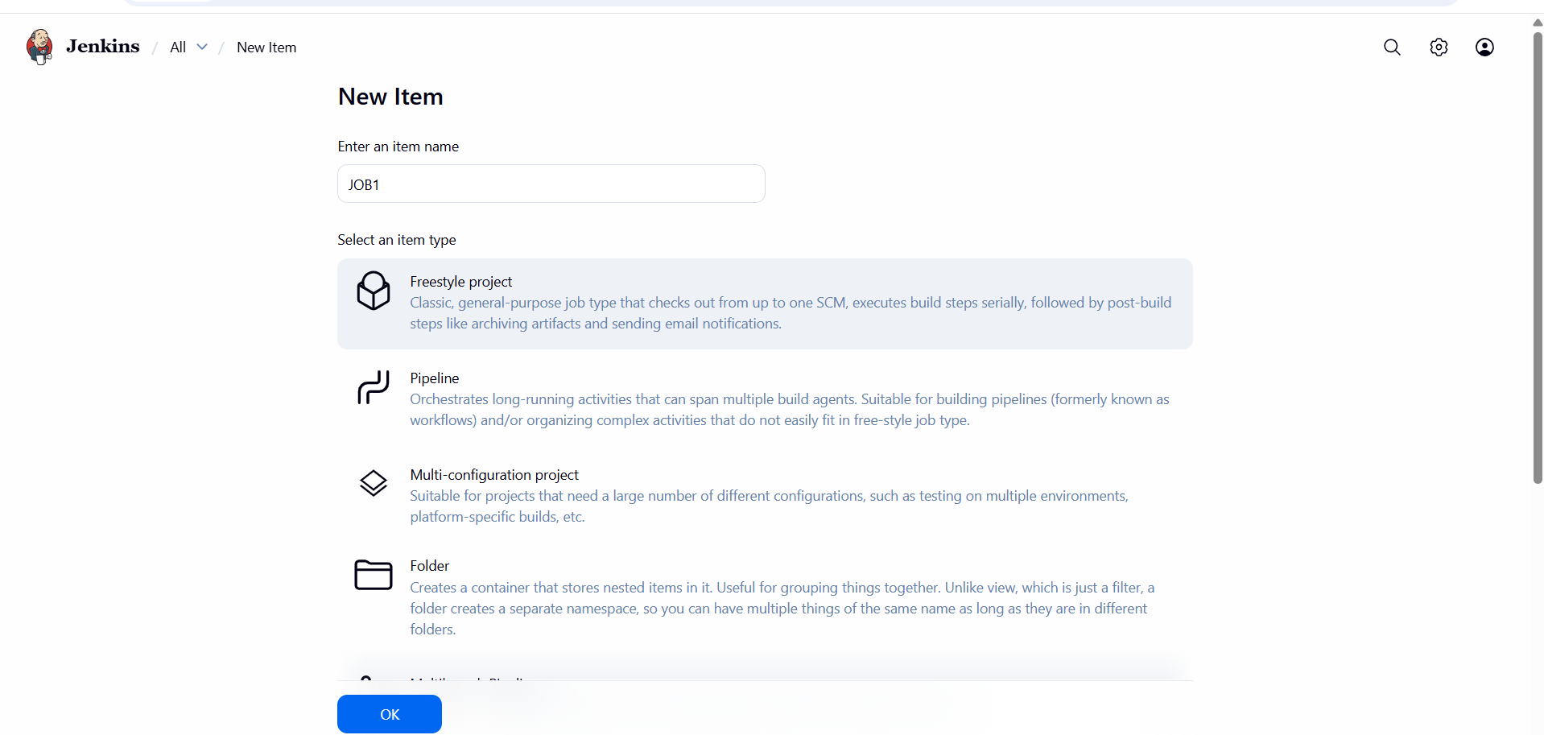
- create the item (job)
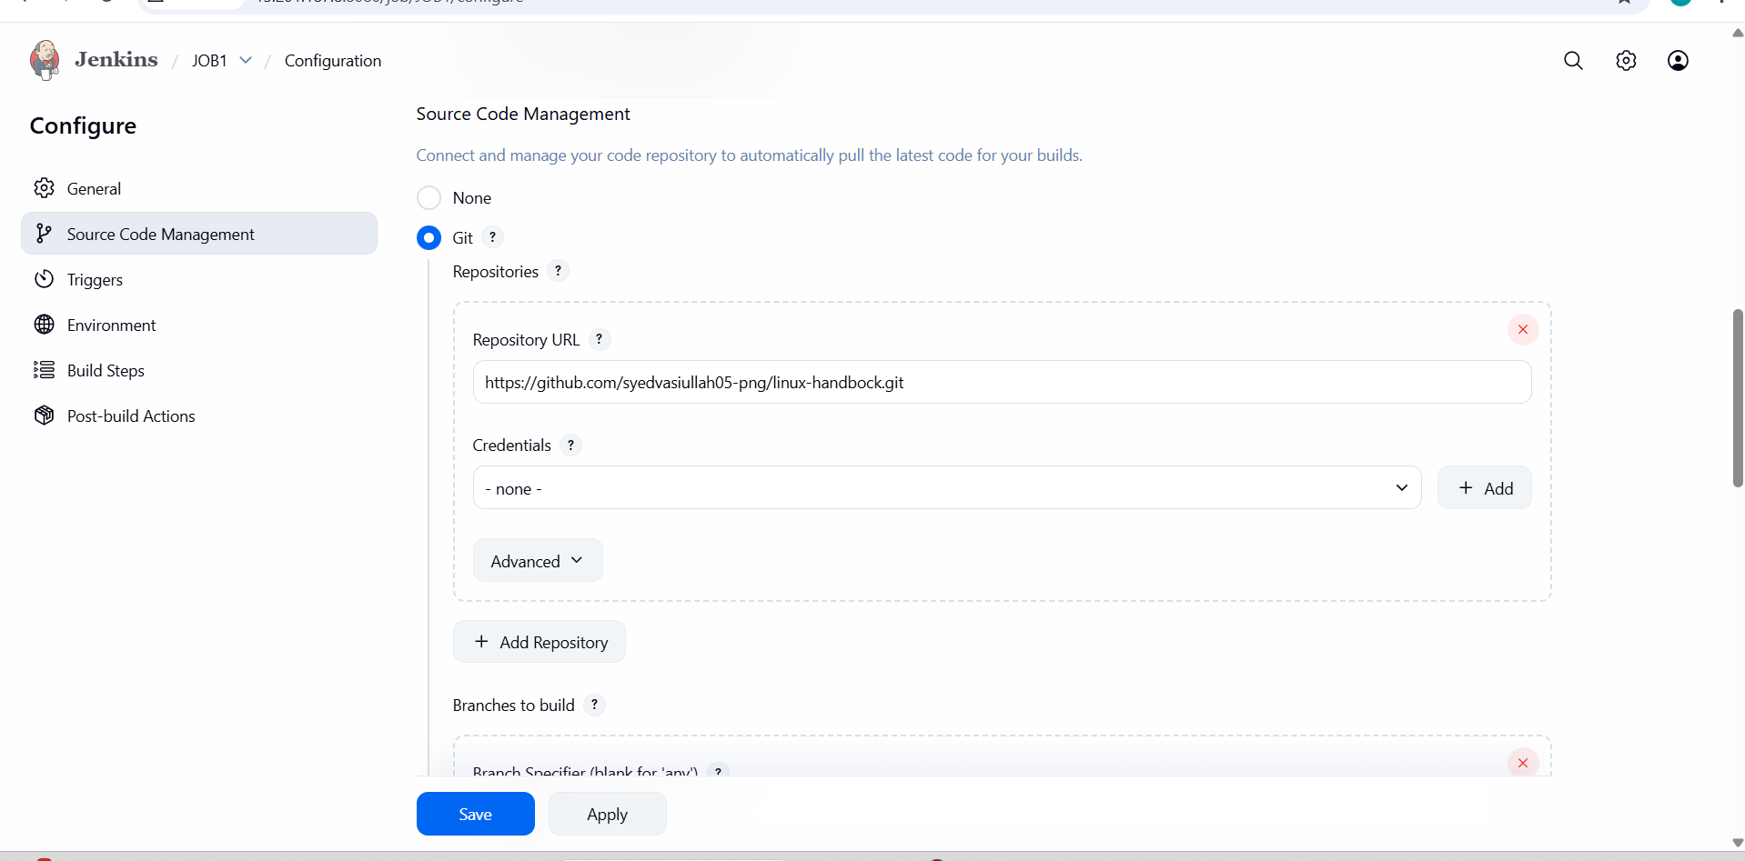
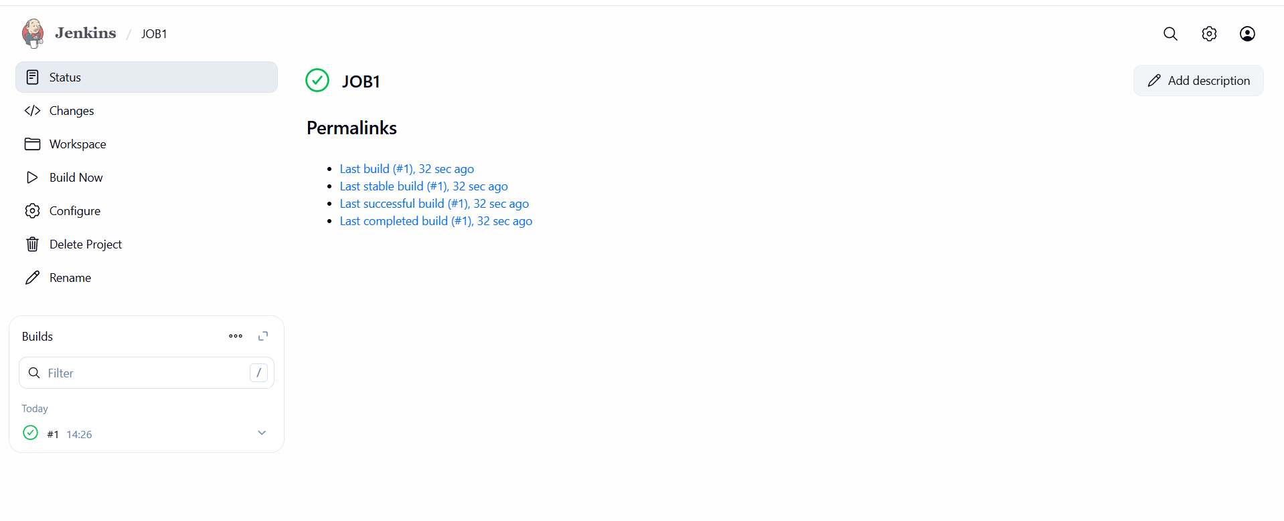

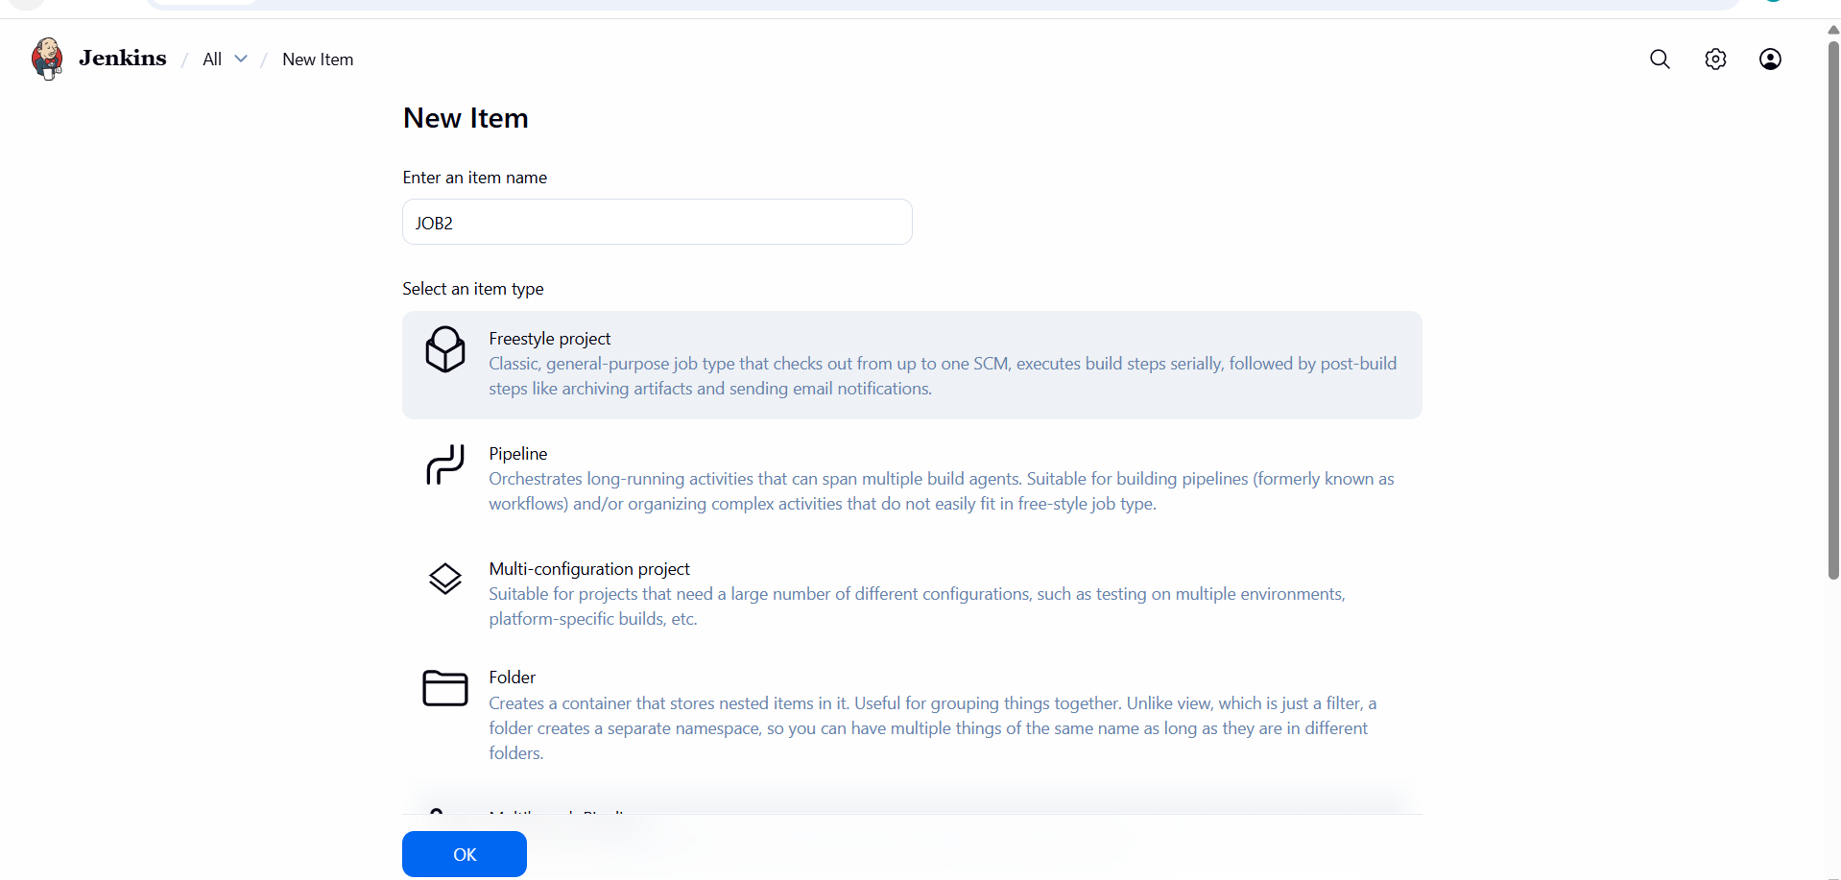
- Now add the label and git url and save
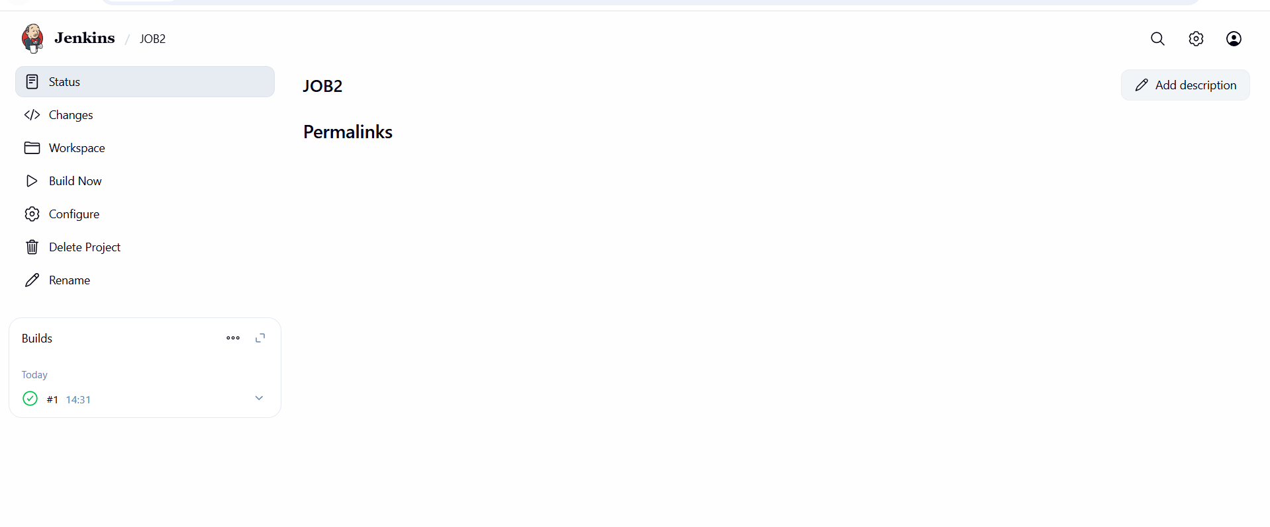
- click build now
- Similar do for other jobs

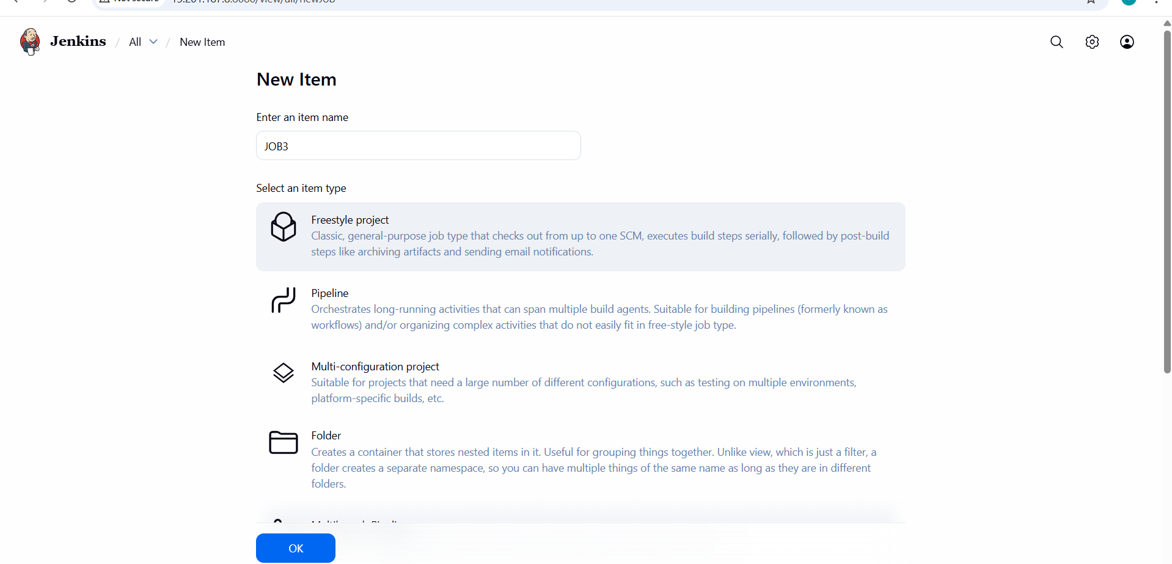
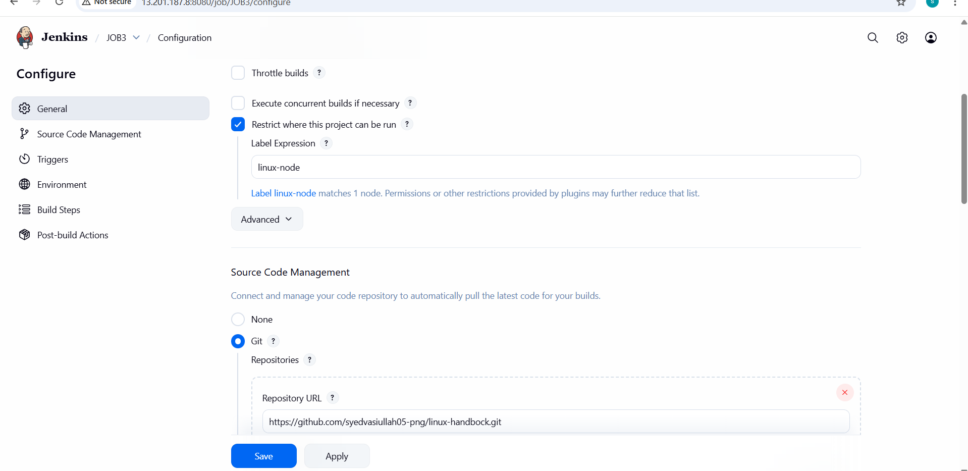
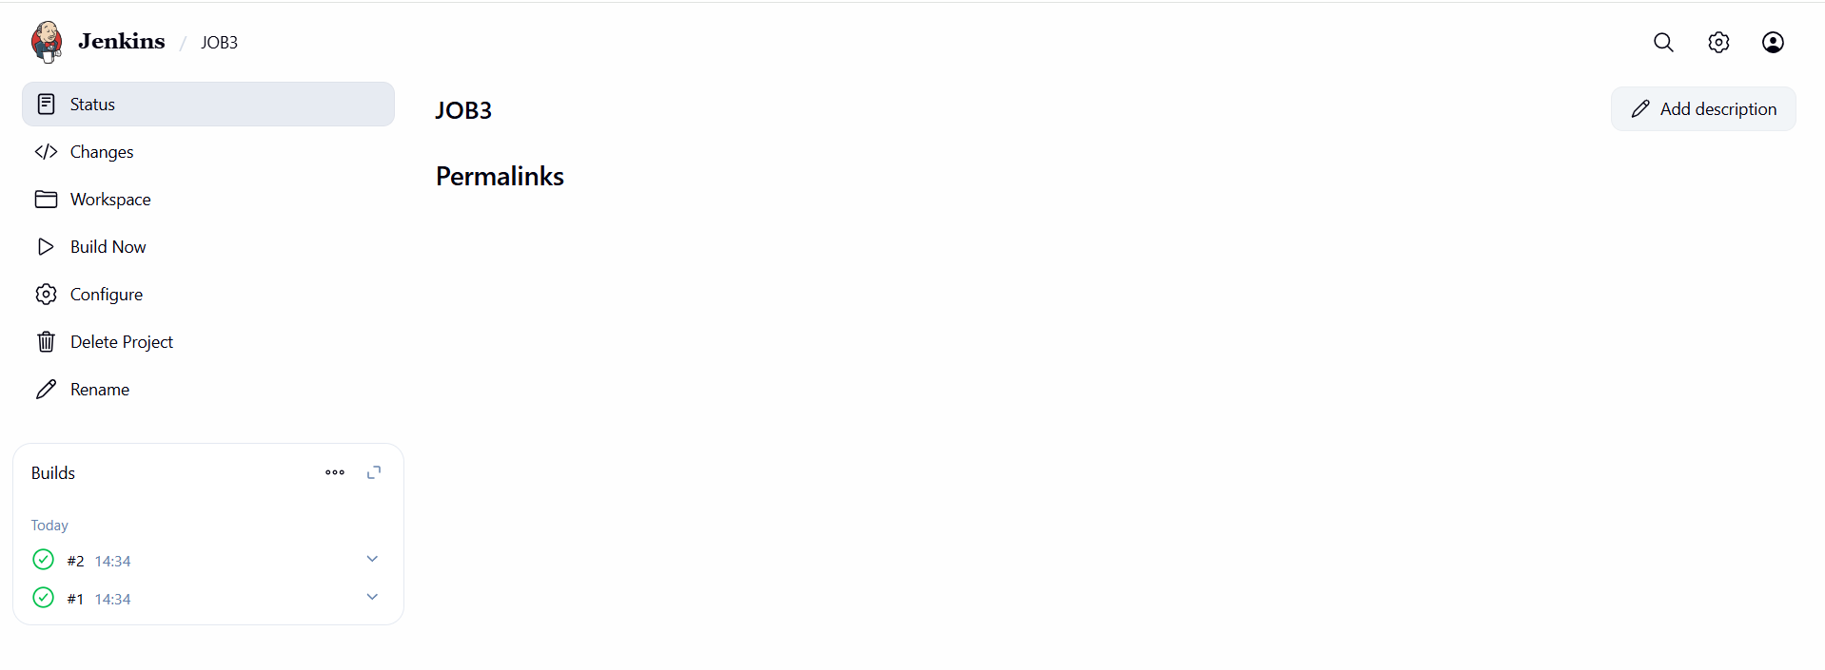
- After create a new job and attach the git url similar to above job also
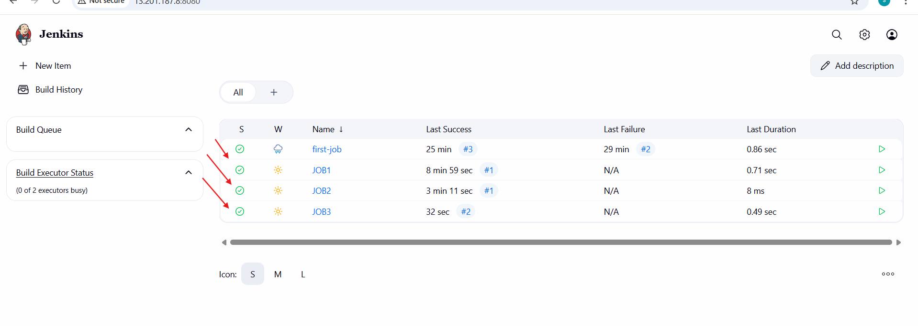
6.Create one Jenkins job using git hub Private repository.
- Go to manage jenkins.
- Then use creden als.
- Then system and create creden als
- And save it
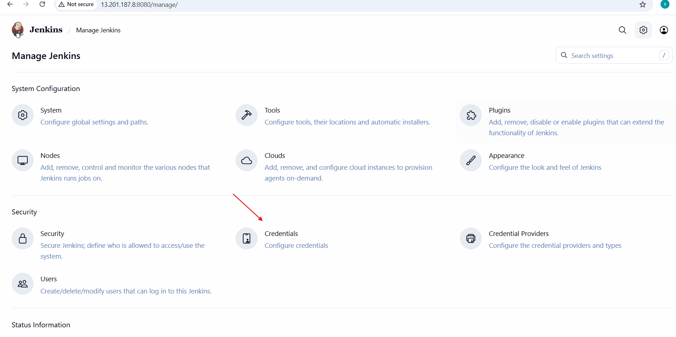
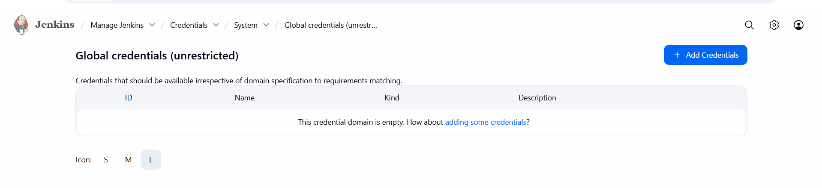
- fill the details of the private repo from user
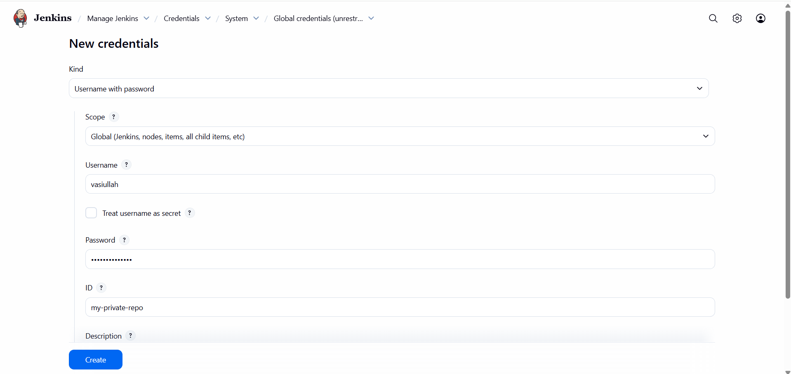

- Go to your GitHub and create a token and copy it and paste on
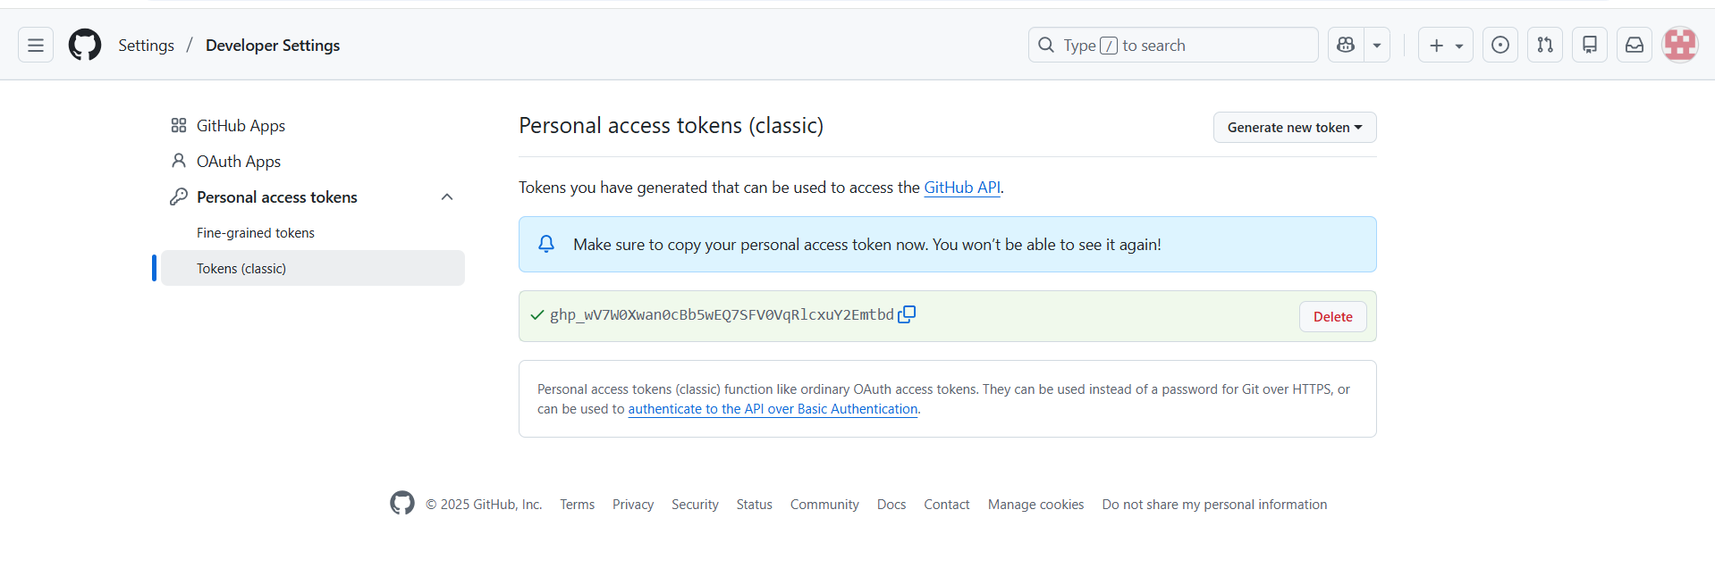
- Above password in credentials
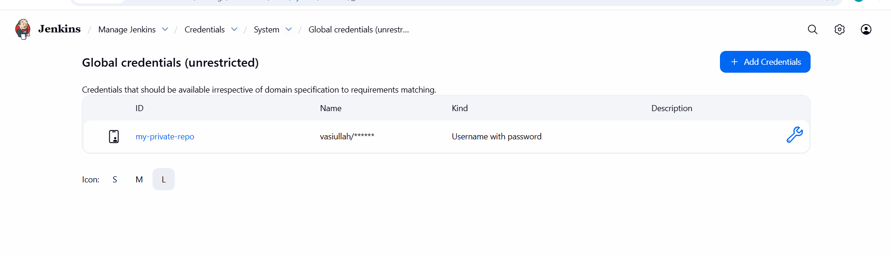
- Go to jenkins dash board.
- Then create a job.
- Use git.
- Give your private repo h p address for that.
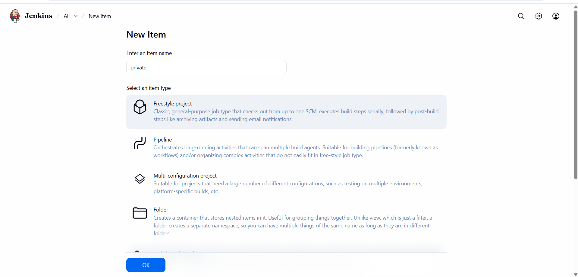
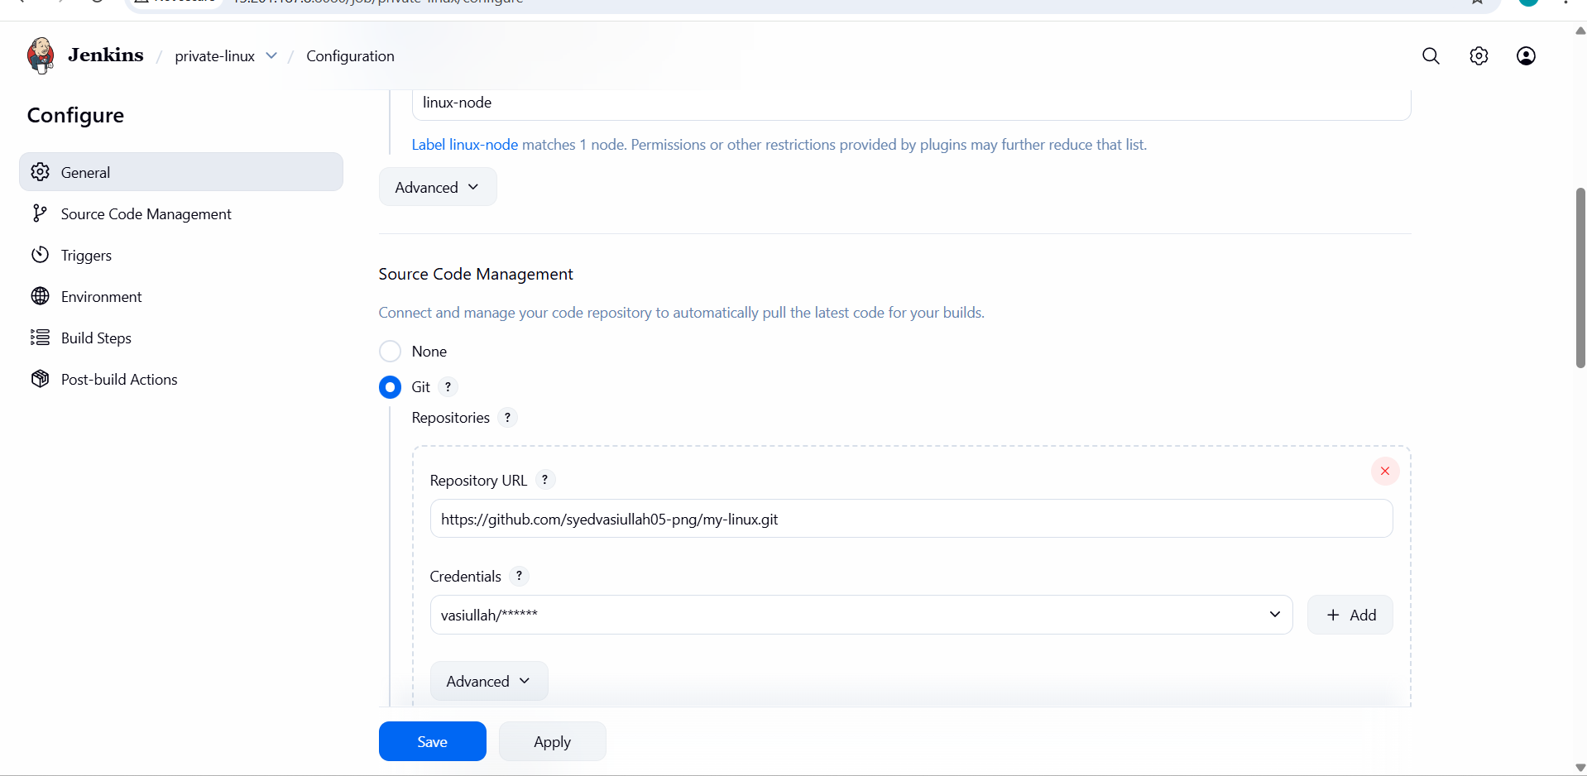
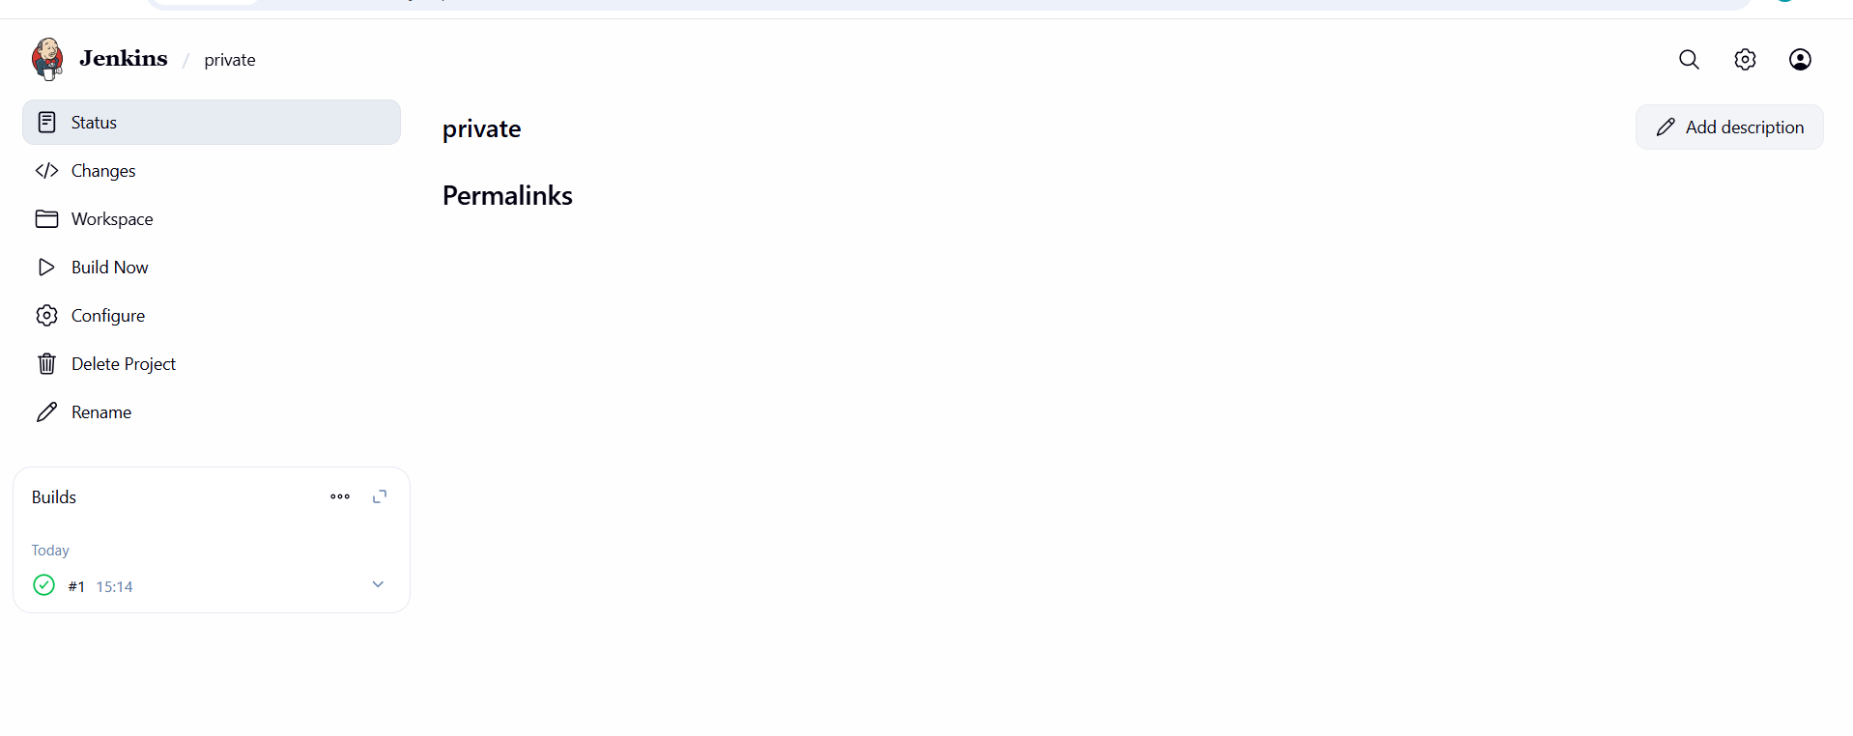
- inside git add the private repo url and add the credentials which we created
- Then go to build >> excute build steps -> console output
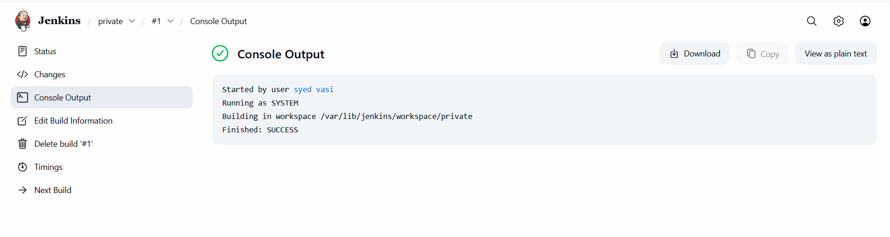
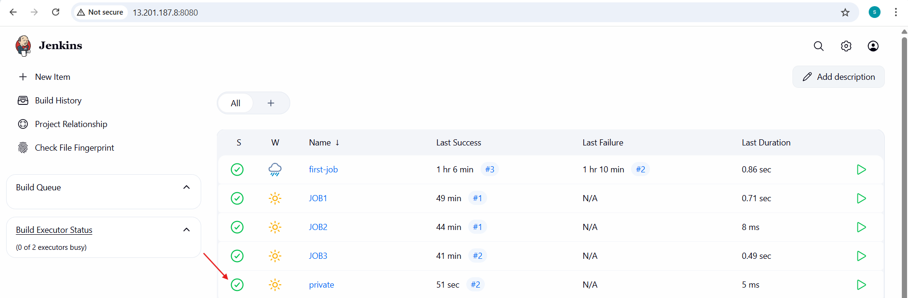
- Hence Create one Jenkins job using git hub Private repository

